**There are Five stages an ios app can enter into:**

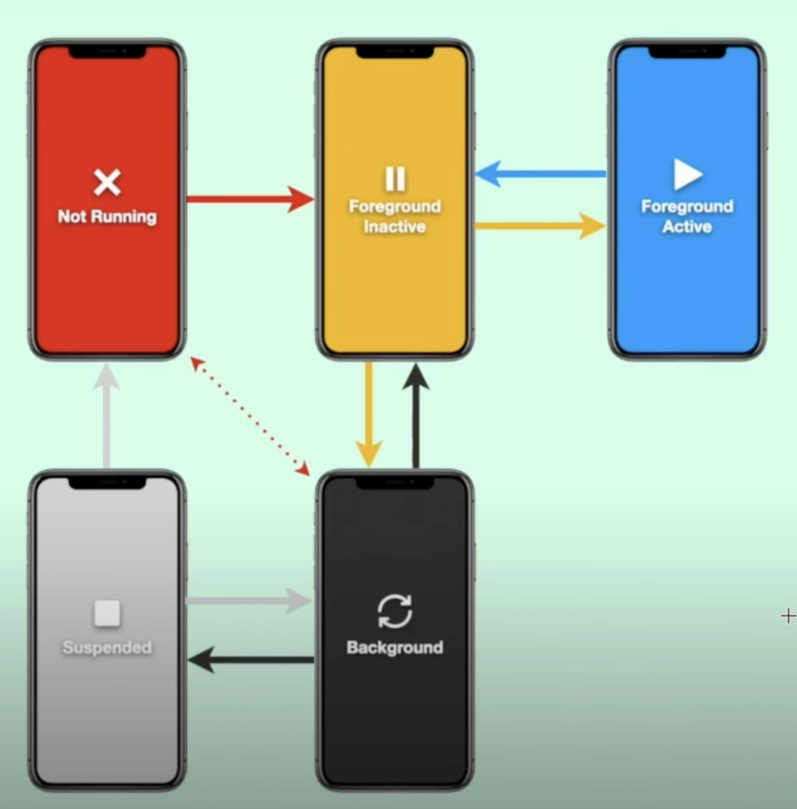

## 

**The various states that you must consider for your app, why you must consider it, and what must happen in each state.**

As the app changes from one state to another, it should be able to adjust its behavior accordingly.

## Not Running

The App is not yet launched or is terminated by the system or user. Launching the app can move the user from ‘not running’ to ‘foreground’ state.

## Foreground Inactive

As the app launches, the information loads and the app is in a short state. The inactive state is where the app is running but it is not ready to take any input from the user. There is no event happening like clicking a button. If you receive a call your current app is in foreground Inactive state. If we look at a notification while running your current app.

## Foreground Active

This is the main executive state where UI is accessible. This is where the app gets all the user information. Example, when a user is playing a game, the user can type in a textfield, the user is buying clothes and much more.

## Background

This is just before the app is getting fully suspended. The app is still allowed to execute code. Example, a fitness tracking app. This state can also be useful in storing any application data and releasing the resources if they are not needed.

## Suspended

This happens when an application is unable to execute any code and can get terminated. If an app is running in background and it is not a priority work and the system needs memory for another application. The app with less priority in background will be suspended.